Standard Operating Procedure for **Colorimetric determination of nitrate in soil extracts or soil pore water in 96-well plates**

**Chemical Name or Process:**

**Colorimetric determination of nitrate in soil extracts or soil pore water**

**Purpose:** The method intends to determine the nitrate concentration in a soil pore water sample or a soil extract. The method is based on a color reaction between nitrite and Griess reagents, after reduction of nitrate to nitrite by Vanadium(III) in acid solution.

**Potential Hazards/Toxicity:**

* **vanadium (III) chloride:** 
  + **DANGER! Harmful if swallowed. Causes severe skin burns and eye damage.**
* **Sulfanilamide:** 
  + **WARNING! Causes serious eye and skin irritation.**
* **N-(1-naphthyl)ethylenediamine dihydrochloride:** 
  + **WARNING! Causes serious eye and skin irritation.**
* **Hydrochloric acid** 
  + **DANGER! Causes severe skin burns and eye damage.**

**Engineering Controls:**

Prepare reagent in the fume hood

**Personal Protective Equipment (PPE)-**

**Hand Protection:**

Nitrile gloves

**Eye Protection :**

Chemical splash goggles

Safety glasses or chemical splash goggles, as directed by advisor/P.I.. Goggles are required whenever there is a potential for a hazardous liquid splash, as per the Chemical Hygiene Plan Sec 3.1.b

**Skin and Body Protection:**

Lab personnel working with the chemicals need to wear full-length pants or its equivalent, closed-toe footwear with no skin being exposed, and a lab coat.

**Hygiene Measures:**

Wash hands after working with the hazardous substances and when leaving the lab/shop.

**Respirators may be required under any of the following circumstances:**

* As a last line of defense (i.e., after engineering and administrative controls have been exhausted).
* When Permissible Exposure Limit (PEL) will or may be exceeded, or the airborne concentration is unknown.
* Regulations require the use of a respirator.
* There is potential for harmful exposure due to an atmospheric contaminant (in the absence of PEL)
* As PPE in the event of a chemical spill clean-up process

Prior to obtaining a respirator, an exposure assessment of the process or procedure must be conducted. If respiratory protection is required, then lab personnel must obtain respiratory protection training, a medical evaluation, and a respirator fit test through EH&S. This is a regulatory requirement.

**First Aid Procedures for Chemical Exposures**

**If inhaled:** Evacuate the victim to a safe area as soon as possible. Loosen tight clothing such as a collar, tie, belt or waistband. If breathing is difficult, seek medical attention. If the victim is not breathing, perform mouth-to-mouth resuscitation. WARNING: It may be hazardous to the person providing aid to give mouth-to-mouth resuscitation when the inhaled material is toxic, infectious or corrosive. Seek immediate medical attention.

**In case of skin contact:** In case of contact, immediately flush skin with plenty of water for at least 15 minutes while removing contaminated clothing and shoes. Cold water may be used. Wash clothing before reuse. Thoroughly clean shoes before reuse. Get medical attention, as necessary.

**In case of eye contact:** Immediately flush eyes with plenty of water for at least 15 minutes. Check for and remove any contact lenses. Get medical attention.

**If swallowed:**

* vanadium (III) chloride:
  + Call a POISON CENTER or doctor/ physician if you feel unwell. Rinse mouth. Do NOT induce vomiting.

**Special Handling and Storage Requirements**

* vanadium (III) chloride:
  + Further processing of solid materials may result in the formation of combustible dusts. The potential for combustible dust formation should be taken into consideration before additional processing occurs. Avoid contact with skin and eyes. Avoid formation of dust and aerosols. Provide appropriate exhaust ventilation at places where dust is formed.
  + Keep container tightly closed in a dry and well-ventilated place. Light sensitive. Air and moisture sensitive. Keep in a dry place. Storage class (TRGS 510): Non-combustible, corrosive hazardous material
* Hydrochloric acid
  + Keep container dry. Do not ingest. Do not breathe gas/fumes/ vapor/spray. Never add water to this product. In case of insufficient ventilation, wear suitable respiratory equipment. If ingested, seek medical advice immediately and show the container or the label. Avoid contact with skin and eyes. Keep away from incompatibles such as oxidizing agents, organic materials, metals, alkalis, moisture. May corrode metallic surfaces. Store in a metallic or coated fiberboard drum using a strong polyethylene inner package.

**Spill and Accident Procedure**

**Chemical Spill Dial 911 and 756-6661**

**Spill** – Assess the extent of danger. Help contaminated or injured persons. Evacuate the spill area. Avoid breathing vapors. If safe, confine the spill to a small area using a spill kit or absorbent material. Keep others from entering contaminated area (e.g., use caution tape, barriers, etc.).

**Small (<1 L)** – If you have training, you may assist in the clean-up effort. Use appropriate personal protective equipment and clean-up material. Double bag spill waste in plastic bags, label and arrange hazardous waste pick-up.

**Large (>1 L)** – Evacuate spill area. Dial **911** and EH&S at 756-6661 for assistance.Remain available in a safe, nearby location for emergency personnel.

**Chemical Spill on Body or Clothes** – Remove clothing and rinse body thoroughly in emergency shower for at least 15 minutes. Seek medical attention. *Notify supervisor, advisor or P.I. immediately.*

**Chemical Splash Into Eyes** – Immediately rinse eyeball and inner surface of eyelid with water from the emergency eyewash station for a minimum of 15 minutes by forcibly holding the eye open. Seek medical attention. *Notify supervisor, advisor or P.I. immediately.*

# **Medical Emergency Dial 911 or 756-6661**

**Life Threatening Emergency, After Hours, Weekends And Holidays** – Dial 911

*Note: All serious injuries must be reported to Supervisor/PI within 8 hours. Note: Any and all loss of consciousness requires a 911 call*

**Non-Life Threatening Emergency** –

* Students: Seek medical attention at the campus Health Center **M, T, Thu, Fr 8:00 am – 4:30 pm and W 9:00 am – 4:30 pm**
* Emergency Medical services in the community are available at any time at hospital emergency rooms and some emergency care facilities.

***All injuries must be reported to PI/Supervisor immediately and follow campus injury reporting. Follow procedures for reporting of student, visitor injury on the EH&S website at:*** <http://afd.calpoly.edu/riskmgmt/incidentreporting.asp>

* Paid staff, students, faculty: seek initial medical attention for all non-life threatening injuries at:
  + MED STOP, 283 Madonna Road, Suite B (next to See's Candy in Madonna Plaza)  
    (805) 549-8880 Hours: M-F 8a - 8p; Sat/Sun 8a - 4p
  + **After MED Stop Hours:** Sierra Vista Hospital Emergency Room   
    1010 Murray Avenue (805) 546-7651, Open 24 hours

***All injuries must be reported to PI/Supervisor immediately and follow campus injury reporting for employee injuries (Workmen’s Comp.). Follow procedures on the EH&S website at:*** [***http://afd.calpoly.edu/riskmgmt/incidentreporting.asp***](http://afd.calpoly.edu/riskmgmt/incidentreporting.asp)

**Decontamination/Waste Disposal Procedure**

**General hazardous waste disposal guidelines:**

* A large hazardous waste container can be found on the windowside bench in 180-241. It has a hazardous waste tag denoting all ingredients. All intermediate waste containers for waste generated during the procedure must be labeled similarly as soon as the first drop of waste is added to the container. Generic waste labels can be found here: <http://afd.calpoly.edu/ehs/docs/hazwaste_label_template.pdf>

**Store Waste**

* Store hazardous waste in closed containers, in secondary containment and in a designated location
* Double-bag dry waste
* Waste must be under the control of the person generating & disposing of it
* If the waste jar becomes full or close to full, make sure Craig Stubler knows and he will replace it. Waste containers cannot be more than 75% full to allow for liquid expansion.

**Dispose of Waste**

* Dispose of regularly generated chemical waste as per guidelines on EH&S website at: <http://afd.calpoly.edu/ehs/docs/csb_no6.pdf>
* Prepare for transport for pick-up. Use secondary containment.

Call EH&S at 756-6661 for questions.

**Empty Containers-**

* Dispose as hazardous waste if container once held extremely hazardous waste (irrespective of the container size) A list can be found at: <http://afd.calpoly.edu/ehs/docs/extremely_hazardous_wastes.pdf>
* All other containers are legally empty once a concerted effort is made to remove, pour out, scrape out, or otherwise completely empty the vessel. These may be disposed of as recycling or common trash as appropriate.

**Safety Data Sheet (SDS) Location**

Online SDS can be accessed at: <http://siri.org/msds/index.php>

or MSDSOnline at: <http://hq.msdsonline.com/csuedusl/Search/Default.aspx>

**Protocol/Procedure**

**PREMISE OF METHOD (from Hawkes Lab, NCSU):** This assay uses a colorimetric change to quantify the amount of nitrate in your KCl extract. Vanadium(III) in an acid solution is used to reduce nitrate to nitrite. The nitrite is captured by Griess reagents resulting in a detectable colorimetric change (chormophores are formed from the diazotization of sulfanilamide by acidic nitrite followed by coupling with NEDD). The intensity of the color represents the concentration of nitrate+nitrite in the sample, which is determined on a microplate spectrophotometer at λ = 540 nm. Note that this assay is for nitrate and nitrite. If substantial nitrite is expected to be present, it can be quantified alone for subtraction by performing this assay without vanadium chloride.

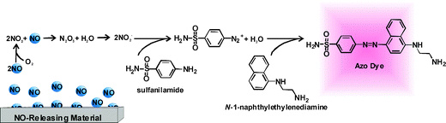

1. **Prepare reagent**

Chemicals:

* Vanadium(III)chloride
* 0.5 M HCl
* sulfanilamide
* N-(1-naphthyl)ethylenediamine dihydrochloride

Procedure

**work in the fume hood, preferably in an anoxic atmosphere (ie under dinitrogen gas)!!**

* Prepare 1 L 0.5 M HCl in volumetric flask
* Weigh 2.5 g Vanadium(III)chloride
* Add Vanadium(III)chloride to volumetric flask and shake until Vanadium(III)chloride is dissolved
* Add 1g sulfanilamide and 0.05 g N-(1-naphthyl)ethylenediamine dihydrochloride to volumetric flask and dissolve
* Use immediately or pour into 100 mL bottles with screwcaps and freeze. Label with:

Sistla Lab, nitrate reagent

Prepared by: YOUR NAME(if Craig, note that)

Date: Month/day/year (20XX)

* Frozen Reagent needs to be removed from freezer the night before sample analysis is planned and can be left to defrost overnight at room temperature.
* If your sample extracts are frozen, can gently thaw in water bath or thaw overnight in fridge.

1. **Prepare standards**

Materials:

* 1000 ppm NO3- standard solution
* Buffer used for soil extraction
* One new or acid-washed falcon tube
* Acid-washed deep-well 96-well plate
* 5ml, 1ml and 200ul pipets and pipet tips
* Bucket for used 5ml and 1ml pipette tips
* Trashcan for used 200ul tips
* Printed plate plan sheet(s), cut out and labeled, attached to notebook appropriately

**Procedure: NO3- plate reader assay**

Make your standards in the range expected for your project. Use the same solution to prepare you standards as used in your samples, namely:

* For soil pore water samples, use DI water for blank and to dilute standards
* For 2 M KCl soil extracts, use 2M KCl for blank and to dilute standards
* For 0.2 M KCl soil extracts, use 0.2 M KCl for blank and to dilute standards
* For 0.5 M K2SO4 soil extracts, use 0.5M K2SO4 for blank and to dilute standards

This solution will further be referred to as the **matrix**.

Once you have determined your matrix, follow the steps below:

1. Prepare a 10ppm stock by placing 0.5 g 1000 ppm NO3- standard in 49.5 g of the matrix using tared 50 ml falcon tube. Mix well.
2. Prepare dilutions of the 10ppm stock in falcon tube as shown below.

**use a 1000ul (blue) pipette for volumes >100ul and a 100ul (yellow) pipette for the 10-100ul volumes**

|  |  |  |  |  |  |  |  |  |
| --- | --- | --- | --- | --- | --- | --- | --- | --- |
| Plate position | 1 A | 1 B | 1 C | 1 D | 1 E | 1 F | 1 G | 1 H |
| ppm NO3- | 10 | 5 | 2.5 | 1 | 0.75 | 0.5 | 0.25 | 0 |
| volume of 10ppm to pipette (uL) | 1000 | 500 | 250 | 100 | 75 | 50 | 25 | 0 |
| Volume of matrix to pipette (uL) | 0 | 500 | 750 | 900 | 925 | 950 | 975 | 1000 |

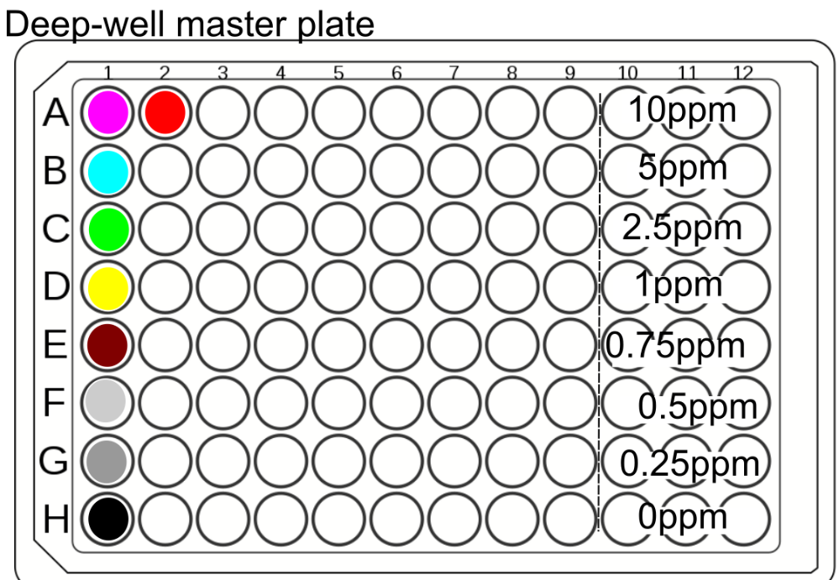

Figure 1. Master deep-well plate. Standards are in column 1. Sample A1-3 (assay plate) is in A2 in deep-well plate.

1. **Process samples**

***Because you are working with such a low sample volume, it is important that you work quickly and efficiently when pipetting to reduce error associated with evaporation. Use lids for 96well plates when you are incubating trays or whenever you are not actively working on a plate***

Materials:

* Standards
* Samples
* Nitrate reagent
* Acid-washed 300ul volume clear 96-well plate, labeled
* Acid-washed deep-well 96-well plate filled with standards (from above)
* 300ul and 100ul Multichannel pipettes
* 200ul pipette tips
* 1 mL pipette
* 1ml pipette tips
* 96-well template (at end of protocol)
* 1 acid-washed pipetting trough

Procedure

* Fill out your **96-well template plate plan**. Record this in your lab notebook and your meta-data file. **It must match the ‘biogeochem_example.xlsx’ NO3_plate_plan file**. (**Negative control in H7-9, standards in A-H 10-12**). If you have more than 23 samples, use additional plates. If you have less, still place your negatives and standards in the same places on the plate to avoid errors.
* For the assay plate (figure 2), use three adjacent columns of the same row for replicates of the same sample, making sure to leave the last three columns for the standards.
  + Ex. sample 1 (magenta) would be marked in wells A1, A2, A3, and sample 2 (cyan) would go in wells B1, B2, and B3.
    - Keep samples in order, make sure they exactly match the Sistla Lab **biogeochem_example.xlsx’** template and is recorded in your lab notebook and meta-data file. *You should double check you also have the fresh weight of the soil samples that were extracted and the gravimetric moisture complete and recorded in the file*.
  + This should correspond to a version of the deepwell master plate plan (i.e., sample A 1 – 3 would be pipetted in A 2 in the deep well plate). You only need to pipette columns in the deep well plate for every three columns in the assay plate. Pipette samples one by one into columns 2, 5, 8 (all rows). Example: Sample1: A2, sample 2 B2, sample 3 C2, etc. **Make a plate map of your master plate in your notebook and record each sample position**.

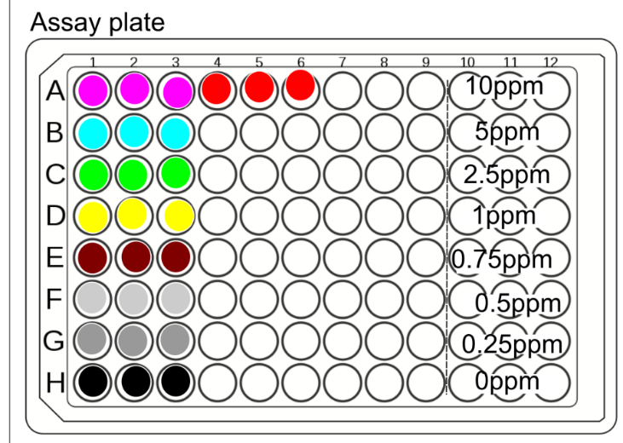

* Using the 5 mL pipette, fill the appropriate well of the **deep**/master plate with 1.8mls (if not freezing the plate afterwards) or 1.5mls (if freezing the plate) of the corresponding sample.
  + You want to also put the standards in the master plate because you want to pipette them identically to the samples with the multichannel.
  + You can use a piece of cardboard/ plate lid to cover filled columns so you can keep track of where you have pipetted.
  + Change tips between samples, and keep the big tips for washing later
* Based on what concentration of NO3 you expect to have in your solution, use the table below to determine the ratio of sample to reagent in the table below. This typically means 20ul sample:200ul of reagent, but check with your supervisor/based on previous data ranges. **Record the ratio you use in your lab notebook and metadata file!**

Sample to Reagent Ratios (recommended by Doane & Howarth 2003)

|  |  |  |  |  |  |  |  |  |  |  |  |  |  |  |
| --- | --- | --- | --- | --- | --- | --- | --- | --- | --- | --- | --- | --- | --- | --- |
|  | Concentration of NO3-N in Sample (ppm) |  |  | Ratio of Sample to Reagent (VCl3) |  | |  | Example volumes for Sample and Reagent (μl) |  | |  | Protocol |  | |
| <1 | | | 5:4 | | | 150:120 | | | | Low | | | |
| 1-5 (this can extend as high as 10ppm if needed, and is probably the range your samples will be in) | | | 1:10 | | | 20:200 | | | | High | | | |
| 1-10 | | | 9:200 | | | 9:200 | | | | High | | | |
| 1-20* | | | 1:50 | | | 4:200 | | | | High | | | |

* Label a pipetting trough with a piece of tape saying “Nitrate reagent”
  + Pour ~20mls of the reagent into its trough and cover with foil
* Using the 300ul multichannel pipette, pipette the appropriate amount of reagent shown in black in the table above (200ul unless you are doing the low nitrate protocol) into all of the sample plate.
* **Sample addition:**
  + Transfer the amount of sample shown in red to the plate (typically 20 ul)
  + Use the same tips for each replicate column of the same set of samples, change tips between samples
  + Make sure that the pipette tips are all well-attached, that you go all the way to the bottom of the wells, and that the same amount of bubble-free liquid is collected by each tip in the multi-channel.
  + Also make sure to keep pipette vertical so you don’t end up with lots of droplets of sample stuck to the outside of the tips.
  + Use cardboard/lid to cover the wells you have filled, both to keep track of where you are.
* Cover the plate with foil and carefully tap its edges a few times to mix the reagent and sample.
* After 6-8 hours (and up to 2 days), read absorbance at approximately 540 nm in the platereader**. Record time incubated and time read in your lab notebook and meta-data file.**

1. **Determine concentration on the Tecan (rm 180-252)**

* Log on to the platereader computer.
* Turn on the platereader by pressing the power switch on the back, just above the power cable.
* If this is your first time running the platereader on this computer or first time in a while, open excel and just check that it is linked to your account and activated (it will ask you to sign in if not).
* Open the Tecan-I-control software
* Click on the infinite 2000Pro at the top and then connect
* Close the protocol pop-up
* Go to file --> open --> nitrate
* Check the settings (plate = “[GRE96ft] – Greiner 96 Flat Transparent”; “plate with cover” checked; all wells yellow in the plate, Absorbance: 540nm, 25 flashes, 0 settle time)
* Open the platereader drawer using the button on the top
* Insert plate with lid and with plate oriented so letters appear on the left and numbers on the top
* Press door button on top of platereader to close the drawer
* Press start button in the software and the plate will start reading
* The software starts writing the data into an excel file. Make sure to rename the tab as the plate ID, and click off the tab name to somewhere into the excel spreadsheet after renaming before starting the next plate (otherwise the program will open a completely new excel file if you read another plate)
* Once the plate has finished, the drawer will open. Put the lid back on the plate and replace the plate with a new one and repeat the read cycle.
* When finished, save the file in the form of [date]_[project]_nitrate_[name initials].xlsx (replace the “[]’ and their contents though!)
* **Upload file to Sistla Lab OneDrive appropriate study folder. Check that standard curve is appropriate in excel (R2 >>0.98, reasonable slope, intercept), negative control absorbance is comparable to 0 NO3- standard. Record that you have confirmed these details in your lab notebook and that the remaining extract, reagents are frozen. Note where they are stored.**
* Close the Tecan I control software. **If it asks you if you want to save changes to the protocol file, say no, but also check what changed (because this could mean you accidentally changed the read conditions prior to reading your plate).**
  + - * + Close the platereader software and let the computer disconnect/stop talking to the platereader. Otherwise others not be able to connect to it.
* Turn off the plate reader and log out of the computer.

1. **Clean-up**
   * Dispose all liquid in plates in the designated waste container (i.e. flick into the beaker and then pour the contents of the beaker in the sealed hazardous waste container). Rinse 1x with deionized water and dispose the first rinse in waste container. Subsequently, rinse the plates three times over the sink with deionized water, and place in the acid bath. Make sure the wells of the plate are filled with the acid solution, as air bubbles have a tendency to form. Repeat the rinsing and acid bathing for the 1 and 5ml tips.
   * When drying tips after rinsing following the acid bath, place them back in the tip box with the lid ajar. Both the tips and plates can be placed in a 50C oven, but don’t let them touch the edges of the oven or completely cover a layer/block airflow, because they will warp/melt!
2. **Calculations**

The linear regression equation is required for calculating NO3-­­ concentration (ppm) in soil extract.

$$\left[{NO}_{3}^{-}\right] (ppm)=\frac{Abs-intercept}{slope}$$

Dry soil weight is calculated using soil moisture and fresh weight.

Or

NO3- concentration (ug/g soil) in soil subsample is determined as following:

$$\left[{NO}_{3}^{-}\right] ({μg}/{g soil)=\frac{\left[{NO}_{3}^{-}\right] in ppm ×extract volume in mL}{dry soil weight in g}}$$

Extract volume can be 20+ mL, the correct extract volume should always be recorded in your notebook and meta data file.

**NOTE:**

Any deviation from this SOP requires approval from PI.

**Date:** Click here to enter a date. **P.I. or Supervisor:** Seeta Sistla

**Documentation of Training** (signature of all users is required)

* The Principal Investigator must ensure that his/her laboratory personnel have attended appropriate laboratory safety training or refresher training within the last one year.
* Training must be administered by PI or Lab Manager to all personnel in lab prior to start

of work with particularly hazardous substance or newly synthetic chemical listed in the

SOP.

* Refresher training will need to be provided when there is a change to the work

procedure, an accident occurs, or repeat non-compliance.

I have read and understand the content, requirements, and responsibilities of this SOP:

|  |  |  |
| --- | --- | --- |
| **Name** | **Signature** | **Date** |
| Click here to enter text. |  | Click here to enter a date. |
| Click here to enter text. |  | Click here to enter a date. |
| Click here to enter text. |  | Click here to enter a date. |
| Click here to enter text. |  | Click here to enter a date. |
| Click here to enter text. |  | Click here to enter a date. |
| Click here to enter text. |  | Click here to enter a date. |
| Click here to enter text. |  | Click here to enter a date. |
| Click here to enter text. |  | Click here to enter a date. |
| Click here to enter text. |  | Click here to enter a date. |
| Click here to enter text. |  | Click here to enter a date. |
| Click here to enter text. |  | Click here to enter a date. |
| Click here to enter text. |  | Click here to enter a date. |
| Click here to enter text. |  | Click here to enter a date. |
| Click here to enter text. |  | Click here to enter a date. |

**Appendix**

Empty 96-well plate plan:

